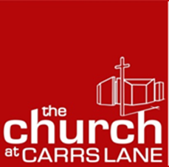
The Church at Carrs Lane
Lay Pastoral Worker
Person Specification
 | Essential | Desirable | Application/  Interview/  References
Education and Qualifications  Able to demonstrate a good level of general education | ✓ |  | A
Participated in higher or further education |  | ✓ | A
Undertaken training in theology or worship leading |  | ✓ | A
Skills and Experience  Experience of working with volunteers |  | ✓ | A
Good listening skills | ✓ |  | I/R
Self-starting with ability to plan and organise own time | ✓ |  | A/I
Good at building relationships | ✓ |  | I/R
Good social media skills |  | ✓ | A
Experience of building networks with a diverse group of stakeholders |  | ✓ | A/I
Experience of working in a city centre context |  | ✓ | A/I
Good group facilitation skills |  | ✓ | A
Good organisational skills | ✓
Qualities and Attributes  Warm, friendly and welcoming | ✓ |  | A/R
Active and committed member of the Christian Church | ✓ |  | A/I/R
Experience of being part of a URC or Methodist congregation |  | ✓ | A/I/R
In sympathy with the vision of The Church at Carrs Lane to be open, inclusive and justice-seeking | ✓ |  | I
Willing to participate in training | ✓

