The Church at Carrs Lane: Access information for worship services.
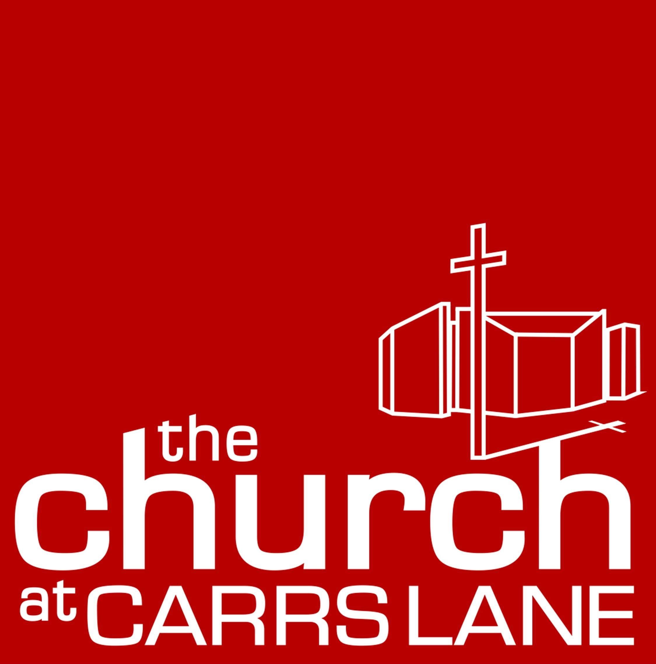

Church website | To find us online use: http://www.carrslane.co.uk
Parking | https://en.parkopedia.co.uk/parking/b4_7sx/?arriving=201907191000&leaving=201907191200  There are some limited parking spaces at church, access via Albert Street and New Meeting Street. They are on ‘first-come, first-served’ basis and there is no charge is attending worship on Sundays. There is not usually access for parking during the week, but if there is, a charge is usually made. Please call ahead if you need to book a disabled space and we will do our best to reserve one for you.
Disabled Parking | As above, the spaces are limited so if you have a blue badge and need a space reserved, please contact us in advance on a ministers email on www.carrslane.co.uk/about-us/team/  On Sunday mornings, the gates to the car park will be unlocked.  During the week, they are usually locked, so please let us know when you call if you would have difficulties in coming to reception for the gate key. Parking is at the rear of the building and the car park area is sloped. Access to the building is around at the front on Moor Street Queensway via a slope.
 | 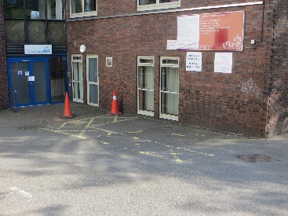  Rear of building with sloped car park and disability parking space |  |  | 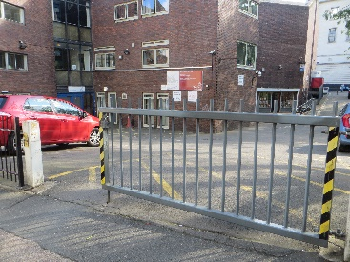  car park gate |  |  |  | 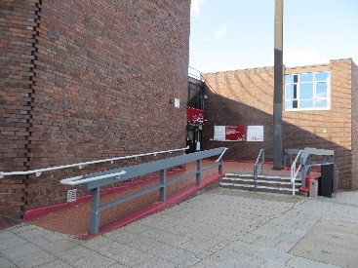  Front door with access slope
Access: | You can drop off passengers at the church before finding parking in one of the two town car-parks within easy walking distance of the church located in Albert Street B4 7LN or Dalton Street B4 7LX .  Enter the church via the front door on Moorstreet Queensway. You may see the ‘back door’ facing the green of Dale Gardens but this is for fire exit only.  The front door has a slope or steps and is suitable for wheelchair/buggy/scooter/walking frame access.  The front door has a call access system. These doors are locked Monday-Saturday and visitors need to press the silver call button on the right of either door. On Sunday mornings for worship, these doors are stewarded so someone will open the door for you.
 | 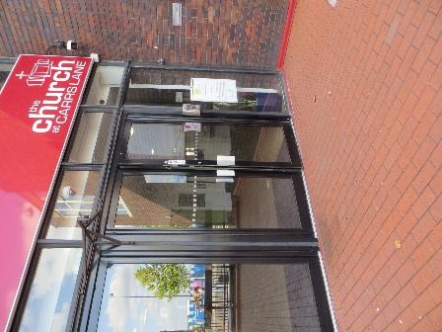  Front door | 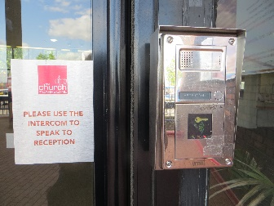  Access buzzer on main entry doors. Press silver button on box on right |  |  | 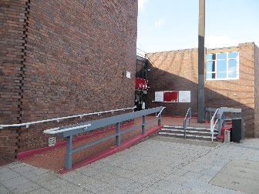  Slope or steps to access the front door on Moor Street Queensway
Flooring: | Outside the front door is made of laid bricks. Inside the front door is a door mat and a carpeted foyer.  The foyer carpet is tight weave and easy to use mobility items or pushchairs on.
 | 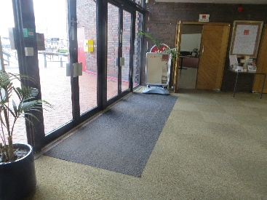  Floor at main door into church |  | 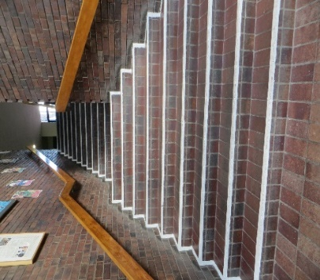  Floor and brick steps from foyer, fire exit to rear door |  |  | 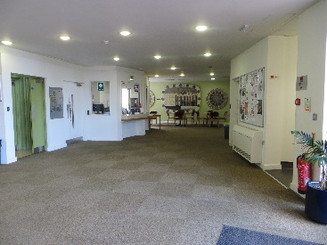  Floor in foyer
Kitchen and seating area | In the foyer area there is some seating and a kitchen hatch. This is where tea and coffee will be served after Sunday morning services. There is no access to the kitchen for visitors but please ask if you need something and we will do our best.
 | 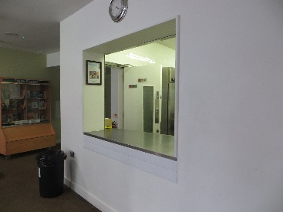  Serving area for drinks |  |  | 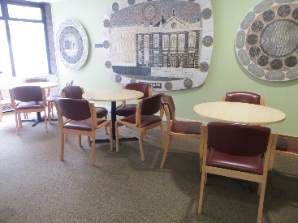  Seating area
Toilets | 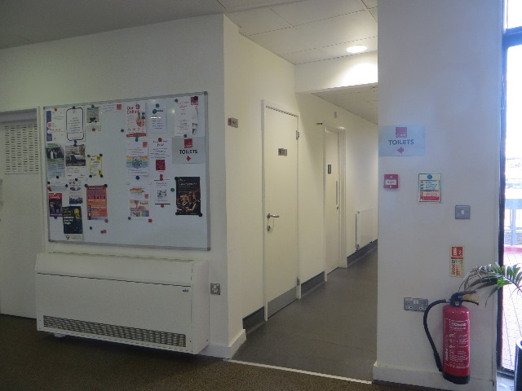  There are 2 sets of toilets. Off the foyer, immediately next to the main front doors are toilets: for males, females, disabled access with a child’s toilet and child changing mat, and Gender Neutral ‘toilets for all’ are downstairs through the green doors and directly ahead downstairs. There are individual cubicles with a shared handwashing area. There is also a toilet with disabled access and a baby changing area. Accessible by stairs from the foyer, or from ground access via an additional door which can be accessed on request.  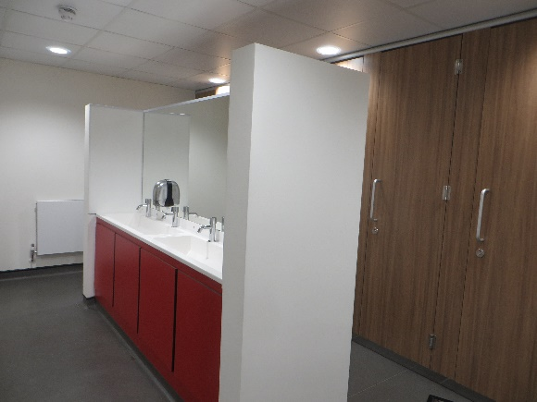  Toilets off main foyer.  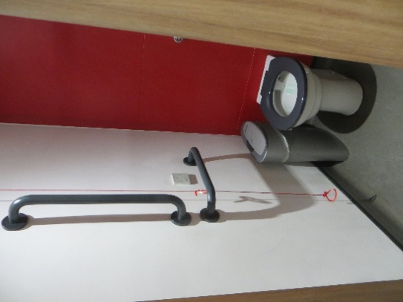  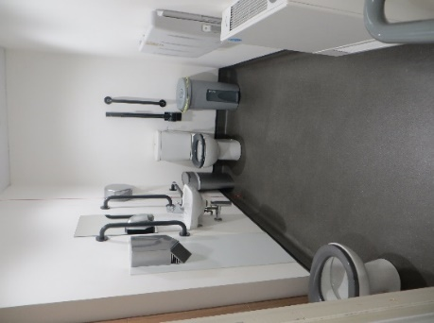  Gender neutral toilet cubicles on lower ground floor. Central hand wash area.
Children on Sunday mornings. | Children are welcome at Church on Sunday mornings. There is a junior church on some Sundays according to availability of leaders. These leaders are DBS checked and the junior church is in a room near the worship area for easy access. If you bring a child to share in the Junior Church, it is your responsibility to ensure that leaders know about any allergies or additional needs you child has. We will do our best to accommodate needs.  There is a children’s area at the back of the worship area which has books, toys, games and craft materials. If you come with children you will usually either be offered the junior church (if it is on that day) or shown this children’s area and a selection of activities for your child.  There is a box of puzzles, complex colouring etc available for older children/younger teenagers. And complex colouring for adults. Please ask if these are not visible.  Whilst it is important for everyone to be able to hear in church, do not worry if your child/children make ‘usual child noise’. We have a sound system which enables people to hear. If you need something for your child, e.g. water, changing facilities, just ask the stewards who will be at the back of the worship area on Sunday mornings.  At other times in the week, please contact the person leading the meeting/group about bringing a child/children unless you know it is a group for children.
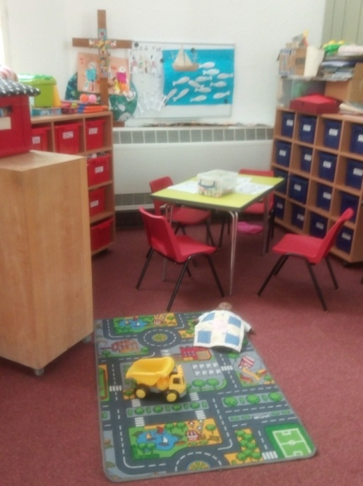
Children’s area

Wheelchair users | We try to use only rooms with wheelchair access for worship and any public meetings.  In all of our meeting rooms, chairs are used.  If a room is set up in board room style (with chairs around tables), wheelchair users can sit anywhere and a chair can be moved to enable this.  If the room is set up with chairs in rows, wheelchair users can sit at the end of any row as a chair can be moved to give space (in the main church room, (used on Sunday mornings for worship) chairs are in sets of 2 or 3, so a small set of chairs can be moved). Wheelchairs can not be placed in the middle of rows as this is not safe in the event of a fire.
Animals/  assistance dogs | The only animals permitted in the building are assistance dogs. If you need water or a bowl of water for your assistance dog, please let us know and we will get one for you. If your assistance dog is in training, please let us know so that we can do our best to meet needs.
Inclusion | We are a diverse, inclusive and affirming Church who love diversity and ask for each to be mutually respecting of differences. People are welcome to be part of church life whatever their gender identity, sexuality, ethnicity, financial situation, neurodiversity, differing abilities, mental health and disability. People are invited to take part in church life in ways which suit their level of commitment, gifts and skills. We want to be fully inclusive but realise that there is always more to learn. If you find you have inclusion needs which are not met, please discuss with ministers via emails on the website www.carrslane.co.uk/about-us/team
Neurodivergence | We are able to loan noise-reducing headphones, sunglasses, squishy toys, and coloured overlay sheets, for use during worship. You are welcome to sit on the floor at the sides/back if this is more comfortable for you. You are welcome to stim – if a church stewards asks if you are okay, and you say you’re stimming, they will understand. We would love you to feel comfortable in church, and for it to be a safe space for all.  We have recently changed our admin system, so do not always have a printed order of service available. If you cannot see one, please ask the door steward – if you have a smart phone, you may be able to photograph the leader’s sheets if there are none printed for general use.
Touch | If you prefer not to shake hands, no offence will be taken. During some services, some people may shake hands as a sign of Peace, but some people instead either hold your hands together and share the words ‘peace’ or ‘peace to you’, or use the BSL sign for Peace, as in the photos below. You can do as you prefer.  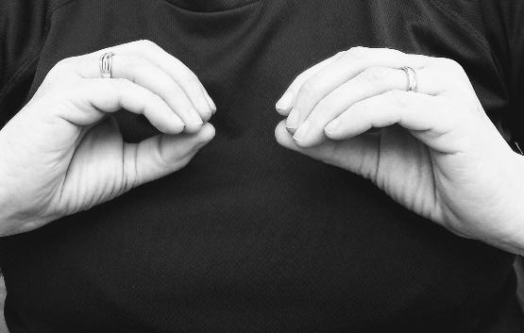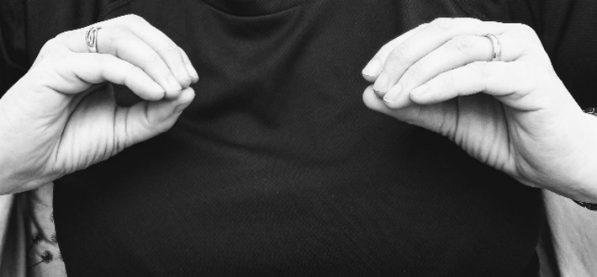
Hearing loop | The loop system is active only in the main church room. Please ask our staff or on Sundays, the people by the church doors for more information.
Large print books | A large print version of the hymn book is available. Orders of service and notices can usually be made available in large print if we have notice. Please contact the one of the ministers via the email addresss on the website www.carrslane.co.uk/about-us/team/  We have recently changed our administration system so are struggling to produce printed sheets each week, but if you need a large print order of service, please let us know in advance and we will do our best: www.carrslane.co.uk/about-us/team/
Braille hymn books | We do not currently have these available. If you need these and are intending to make this your regular church, please discuss with ministers.
Sunday/  Wednesday communion | Communion involves prayers of thanksgiving being shared and then bread and wine is shared. The bread is always gluten free and the wine in small cups is non-alcoholic. We have an ‘open table’ which means that anyone can be part of this. You do not have to already be a committed Christian or a church member.  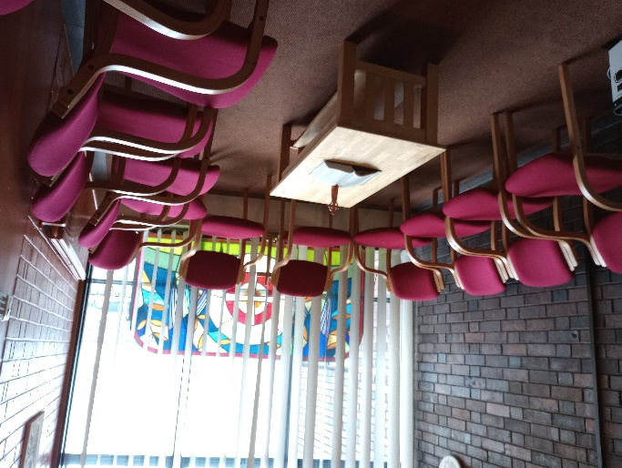  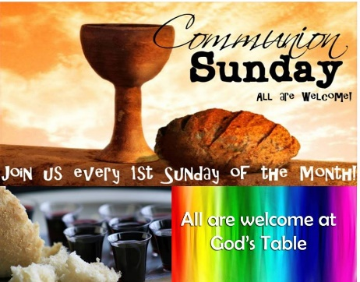  The Quiet Room is usually used for Wednesday Invitation for Sunday Communion – it is an open table  Services on 2nd and 4th Wednesdays each month. (see above).  These sometimes involve communion.  Please check if you are travelling  in especially: www.carrslane.co.uk/about-us/team
Sounds during worship | You may expect to hear these sounds during worship:  *speaking: readers and preacher/leader will use microphones at the front. There is a hearing loop connected to these.  *pipe organ. Including pedal – some bass notes.  *Piano – used in main church room on Sundays, and an electric piano during Wednesday services.  *singing: main congregation singing, choir (usually seated on the left of the worship area, often sing in harmony).  *Additional musicians play occasionally, eg trumpet or violin. If it would be helpful for you to know about this, please ask the person who offers you a hymn book as you enter the church and they will find out for you.  *Heaters: as they blow air they make sounds which vary as they cool/heat the room.  *City centre: general city sounds eg sirens, traffic, people talking, buses, and occasionally a steam train arriving at Moor Street Station. Although these are generally not disturbing, you may notice these sounds.  *Hand driers in the downstairs toilets can be heard in the downstairs foyer as there are no external doors to that set of toilets.  *Fire alarm: a very loud siren which can be heard above all other sounds. If it sounds, please leave by a signed fire exit and congregate at the back of the building on the green.
Lighting | The main church room has good natural light and may or may not need the electric lights used depending on the daylight.  Other rooms have limited natural light and so usually need electric lights on.  As above, toilets have PIR lighting which comes on as you access the areas. It will also turn itself off.  Sunglasses are available for loan if you prefer dimmer light.
Money | You are not expected to give any money to the church when visiting. There is an ‘offering plate’ at the back of the worship area where you can choose to give a money-gift to the church, but no one will ask you to do that. Offerings to the church are appreciated – many long-term members give regularly by direct debit, others give when they can. We know everyone’s circumstances are different and we all give as we can, when we can.
Dress | It’s fine to come dressed in any way that is comfortable and a rough guide is what you might wear if going to visit a friend or meeting in a cafe. A bikini or just swimming trunks may make you a little uncomfortable! (and possibly chilly!) but casual clothes, or smart clothes, are all fine. The Church is already a diverse bunch – some people wear jeans and a tshirt, others wear a dress or a suit.
Tattoos | There are no issues about tattoos and some of our existing members have them. The Church may be interested and ask you what a visible tattoo means to you, but you’re welcome to respond that you’d rather not say.

If you have questions, please do ask: email one of our ministers on: www.carrslane.co.uk/about-us/team

We realise we will need to review this document and add things as questions are asked and needs arise. If there are things you think we should add, please let us know. Thank you.

