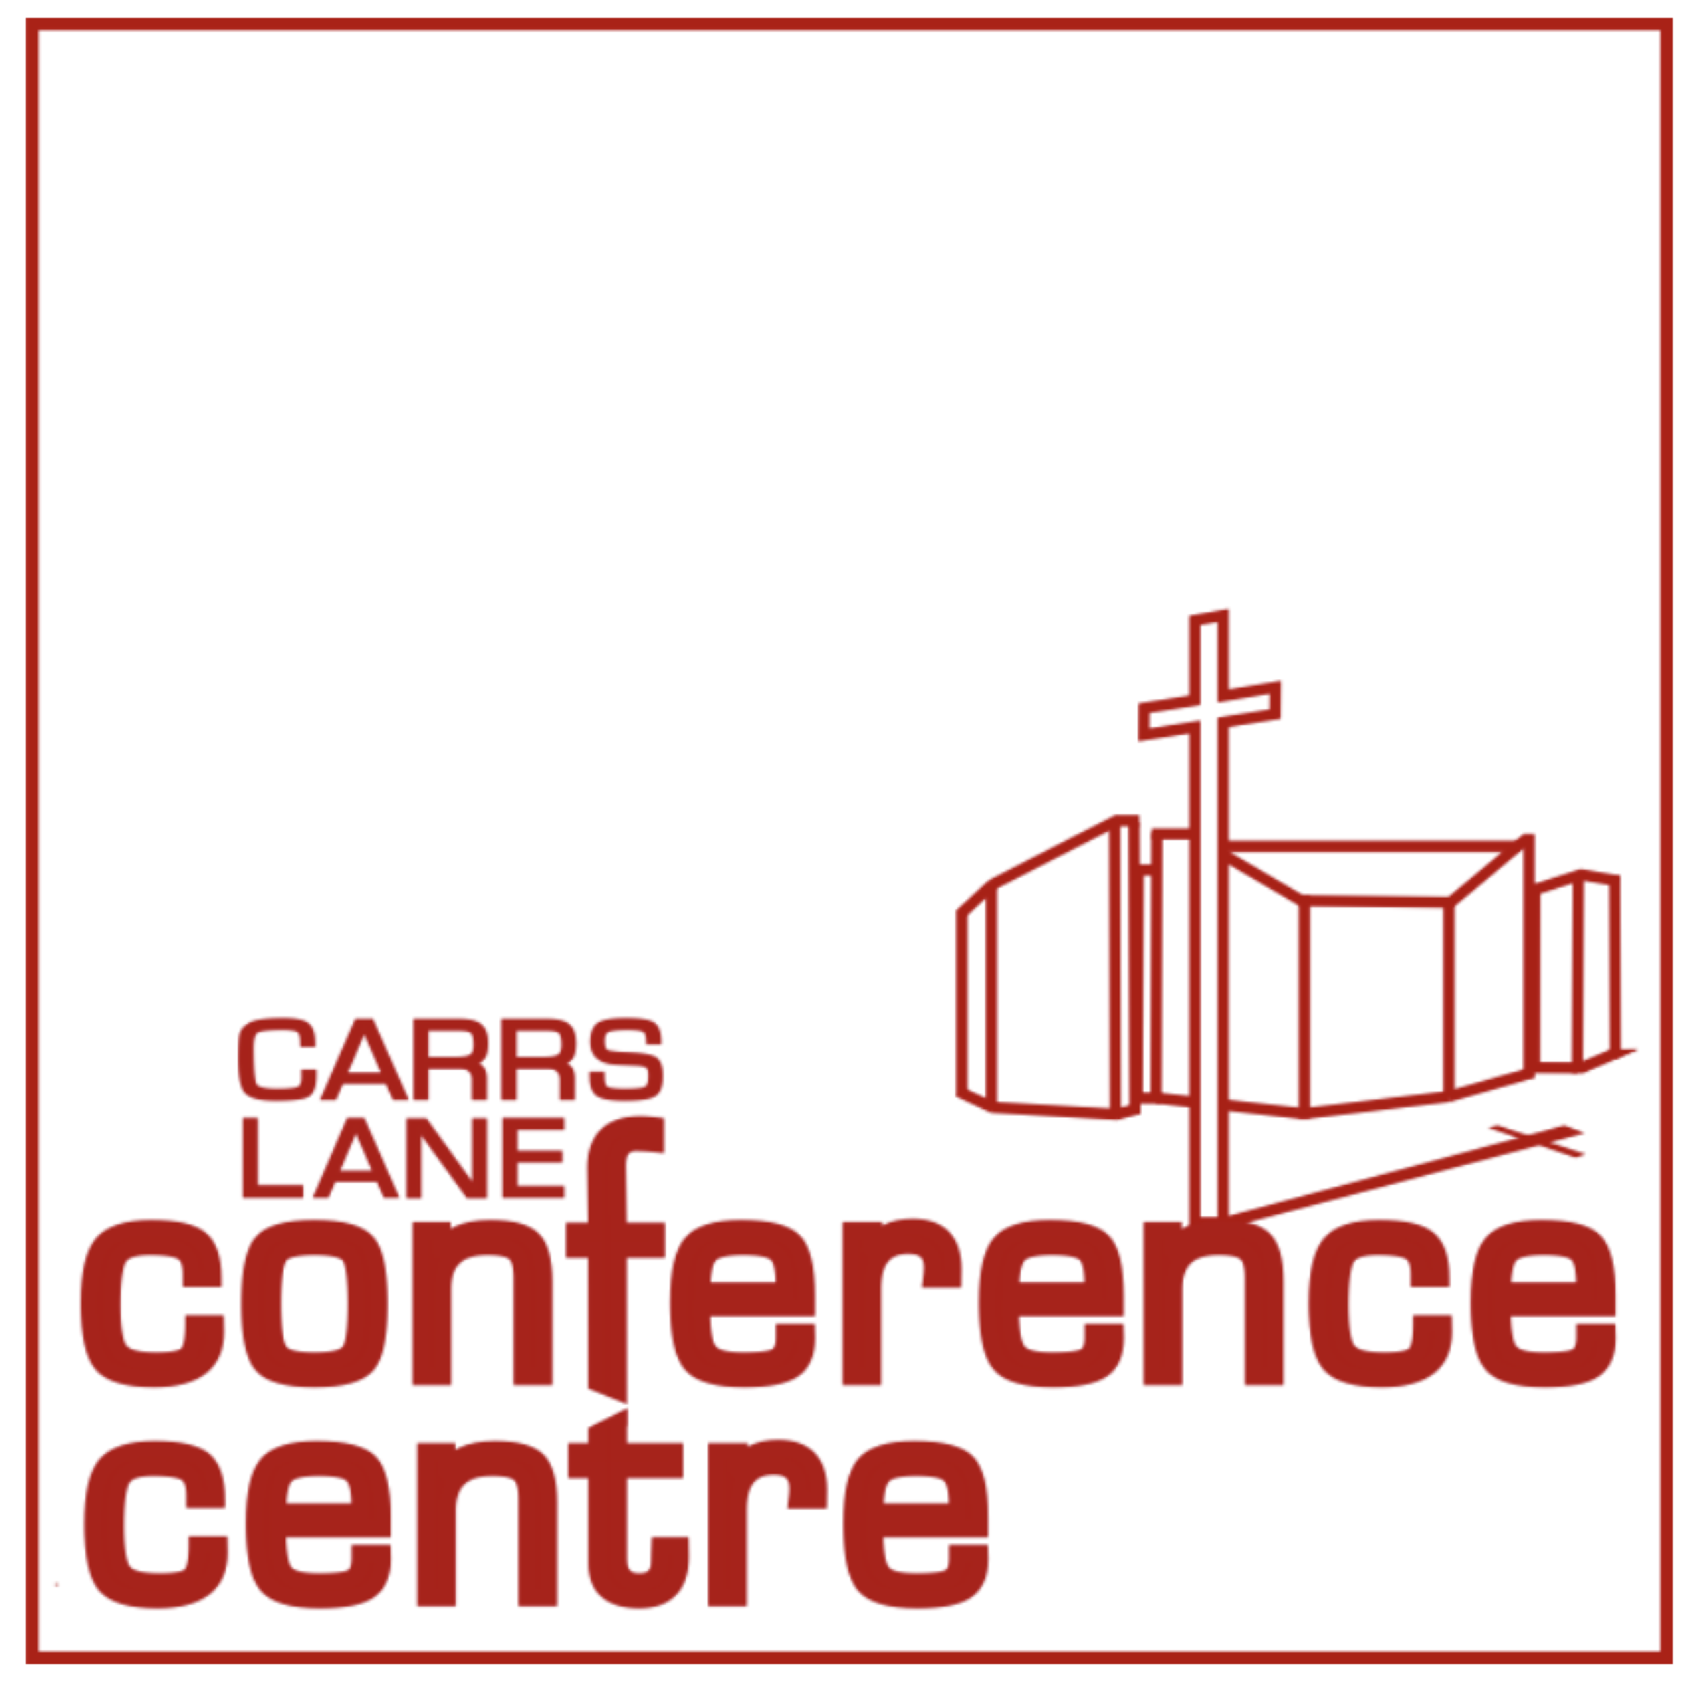
The Church at Carrs Lane
Carrs Lane
Birmingham, B4 7SX
Telephone: 0121 643 6151
Web: www.carrslane.co.uk
Email: booking@carrslane.co.uk

APPLICATION FORM FOR NEW CUSTOMERS WANTING TO HIRE ROOMS

Name of Organisation:-

Registered Company No |  | Registered Charity Number
Address of Organisation (or Chair of Trustees or other responsible person – please state)

Telephone number:- |  | Fax number
Website |  | Email address
Name of Contact person:-

Address if different from above

Telephone | Fax |  | Email
Main purpose of organisation

Purpose and type of meeting/activity you plan to hold at The Church at Carrs Lane

Number of people attending |  | Will the meeting be open to the public?
Will children be attending?
If YES please enclose a copy of your Child Protection Policy
How did you come to hear about The Church at Carrs Lane?
Recommendation………… Church Website……………….
Yell . website ………….. Yellow pages directory………………. Other…………………….
Reference contacts – (These MUST NOT be members of the organisation applying). Please supply two referees from a professional body or organisation who have had dealings with you and can confirm your organisation’s status (eg. Bank Manager, Senior Minister of another Church, Solicitor etc.)
Contact name:  Position:  Organisation:  Address:  Telephone:  Email: |  | Contact name:  Position:  Organisation:  Address:  Telephone:  Email:
Please attach a copy of your organisation’s constitution
Please sign below to confirm that you have read and agree to the Terms and Conditions overleaf

Signed Print Name Date

Carrs Lane Conference Centre - Room Hire Terms and Conditions
- Eligibility Carrs Lane Conference Centre is the room hire and conference facilities part of The Church at Carrs Lane. Rooms may be hired by religious or secular organisations which accept the general principles by which the The Church at Carrs Lane operates. These are based on a commitment to:
* Equal opportunities * Racial equality * Non-violence * No abusive behaviour * Respect and tolerance for all.

- Organisation registration First time hirers must provide organisation details on The Church at Carrs Lane application form before they can book a room. Organisations must not be involved in any activity that could cause offence to the Centre staff or Church members. The Trustees of The Church at Carrs Lane have final discretion over which organisations may use the Centre.
- Religious organisations Any faith group is welcome to hire the rooms for meetings or worship, provided it respects the traditions and faith patterns of The Church at Carrs Lane. None of the religious symbols in the Church Room (or other rooms if present) may be moved or covered. Faith groups which are not part of a mainstream Christian church (as listed by Birmingham Churches Together, www.birminghamchurches.org.uk/about-us) must provide a statement of their aims and beliefs; and if some form of worship is planned, an order of service. The Trustees of The Church at Carrs Lane will have to decide whether this is acceptable on the premises, before the booking can be made.
- Sufficient rooms, space and time You must book enough space for all your activities, including space for the serving of meals and refreshments. You may use only the room(s) you have hired, including for eating and literature distribution. You must allow sufficient time for setting up and clearing the room(s) within the official session time.
- Room changes If numbers attending differ significantly from the room's capacity, The Church at Carrs Lane may substitute a different size room and charge accordingly. The Church at Carrs Lane also reserves the right to substitute a room of similar capacity if necessary.
- Emergency closure The Trustees of The Church at Carrs Lane cannot be held responsible for any losses to a room hirer consequent upon the forced closure of the Centre through circumstances beyond their control. (Charges may be waived if appropriate.)
- Food If you arrange your own catering or buffet from an external caterer you must pay a catering cover charge - see Catering Menu. Note that the main foyer or any room not hired must not be used as an eating area.
- Noise If you will have music or other loud activities, you must state this when booking, as it may affect the choice of room. If sound from your room affects other meetings, you will be asked to reduce the sound level.
- Disabled Access If you expect to have any attendees with limited mobility, you must state this when booking, as not all areas will be easily accessible to them. (See Room Details . . With disabled access on the website.)
- Children If children will be present you must state this on booking; and show us your Child Protection Policy. In accordance with such policies, unaccompanied children are not allowed in any part of the building.
- Confirmation of booking All bookings are provisional until confirmed by returning the signed booking form to The Church at Carrs Lane.
- Cancellations must be confirmed in writing, by email, post or fax. Should you have to cancel any booking, a cancellation charge will be payable according to the following scale: 1-14 days' notice – 100% charge. 15- 27 days - 50% charge. 28 days or more - no charge. Catering orders not cancelled by Noon the previous working day must be paid for in full.
- Amendments must be confirmed in writing, by email, post or fax. The Church at Carrs Lane reserves the right to levy an administration charge of 20% of the booking session price but not exceeding £25.00.
- Parking Very limited parking may be available at the Centre, for which there is a modest parking fee.
For details of public car parks see the Travel and Travel by Car pages on the website.
- Deliveries Please phone the Booking Office to discuss arrangements for any deliveries which must be clearly labelled with your name and date of your meeting.
- Security Organisers of meetings must report to Reception on the main foyer on arrival and at the end of the meeting. The security of the room and its equipment remains the organiser’s responsibility at all times. If a room is vacated without Reception being notified immediately, and equipment you have hired is stolen, the organiser will be held responsible. Care must be taken of all your belongings and those of your attendees at all times. The Trustees of The Church at Carrs Lane cannot be held responsible for any loss of or damage to your property.
- Health and Safety It is the responsibility of the organisation hiring the room to ensure that our Health and Safety requirements are observed. This includes safe set-up of equipment, the safety of all attendees, and keeping all fire doors and exits clear. Please note the Emergency Evacuation Procedures, and other Health and Safety requirements, which will be found in the room. Any accidents or injuries must be reported immediately to Reception.
- Conduct The organisation hiring the room is responsible for the orderly conduct of their attendees, and ensuring they respect any regulations imposed by any public authority, and that nothing is done which may constitute a breach of the law. The organisation shall fully indemnify The Church at Carrs Lane against any claims, loss or damage arising as a result of a breach of this clause. (The Church at Carrs Lane holds all certificates required by law, including a Public Entertainment Licence.)
- Smoking and Alcohol are not allowed anywhere in the Centre.
- Housekeeping All rooms hired by you must be left as found, with all equipment intact and all the hirer’s equipment and major rubbish removed. Blutack etc. is not permitted on the walls. If the building or the Centre’s equipment is damaged or left in a messy state, you will be charged with the cost of repairs or cleaning.
- Agency Commission Bookings made via Marketing Birmingham are subject to a commission payment of 8% of the total value of the booking (including cancelations). This will be added to your invoice. See www.marketingbirmingham.com
- Payment Terms are strictly 30 days from date of invoice. Please ask Reception for your invoice when you leave.

